

**RMIT INTERNATIONAL UNIVERSITY VIETNAM**

**ASSIGNMENT COVER PAGE**

|  |  |
| --- | --- |
| **Subject Code** | COSC2083 |
| **Subject Name** | Intro To IT |
| **Location and Campus** | Sai Gon South Campus |
| **Title of Assignment** | Individual Paper |
| **Type of Assignment** | My profile |
| **Student Name** | Truong Chan Hoang |
| **Student Number** | s3878262 |
| **Lecturer** | Long Nguyen Minh |
| **Assignment Due Date** | July 25, 2021 |
| **Date of Submission** | July 24, 2021 |

**1.Team name:**

I would not mind any name for my team, but the one that comes in to my mind at the moment is “Connect Tech”, it is very easy to understand and it is quite relevant to the environment that I am studying which is with technologies.

**2.Team profile:**

Before forming into a group, I myself learn things a lot faster and better by listening to people. I am a bit shy in team that I do not know anyone in the group then after I will get more comfortable, I always try to do my best and will mostly forgive somebody if they have done something wrong but not on purpose. So while making teams, if I could get somebody that is really not that introvert would be very good so that person can really make a connection between teammates so it is easier to work as a team, also people who are welcome teammates and try to help and explain if somebody is lost. A team with people who always have respect toward each other will be extremely important so that ideas are share comfortably. Lastly, as I mentioned, I do not anyone of us to feel bad when they did something wrong not on purpose but to make that an opportunity for them to learn so they will not make the same mistake in the future.

**3.Project idea:**

With this project, I chose making a game. There are many types of games in the world that were published and favorite by a big percentage of people but MMORPG was one of the best genres that people want to play on PC because there are so many things to grind for and it takes a lot of time to progress, and each time we progress there is huge different from what people have played before so everyone want to explore and progress to try out everything they could.

**4. Tools**

[Editing Assignment/README.md at 2 · jackeyzhang612/Assignment (github.com)](https://github.com/jackeyzhang612/Assignment/edit/2/README.md)

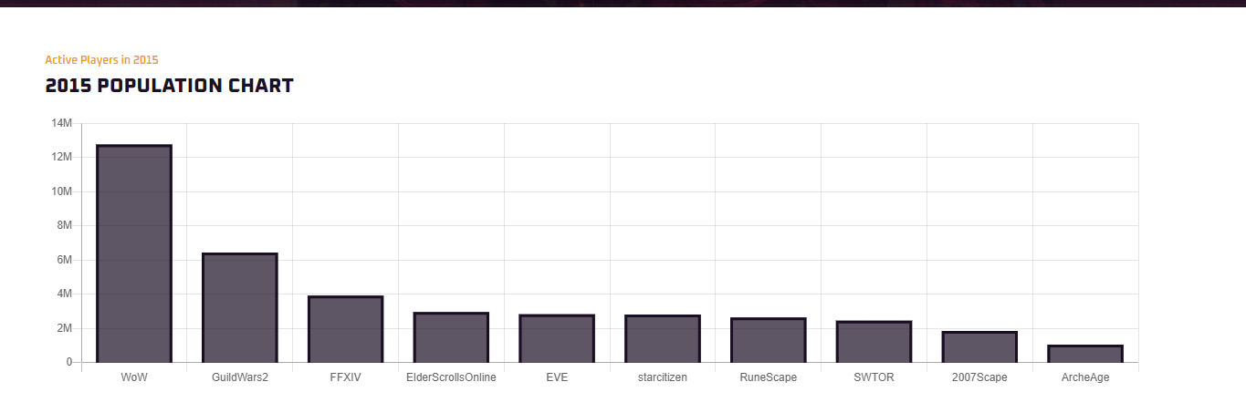

An excellent example for the biggest MMORPG in 2015 is WOW (World of Warcraft), there were more than 12 millions people played WOW and it was on top for a very long time. Even in 2021, the best MMORPG to play is WOW, it is classic, “Over a decade old and still the most popular MMORPG game in the world, World of Warcraft is a bit special.” ((PCGamesN, 2021). Within 20 years, WoW making very big changes to the base game. Making new characters, a lot more races than before, many new continents to explore, etc. Players can travel to the past or future depend on what they want. and now you can go through it so fast it's easy to miss out on some of the surprisingly outstanding story missions that have emerged. But the only way to play the game is only through PC and the game is not fully free since you have to pay monthly to play the game regularly. At the moment, the COVID-19 pandemic is also very hard to control and most of the country in the world is getting back to lockdown again. More than half of players (55%) said they played more games during the pandemic, and most players (90%) said they will continue playing after the country opens up, according to a survey of 4,000 U.S. adults conducted by market research firm Ipsos in February for the [Entertainment Software Association](https://www.theesa.com/). For players during the pandemic, video games were a source of stress relief (55%) and distraction (48%), the survey found. Video games also served as an escape and a break for children, 71% of parents surveyed said. More than half of parents (59%) said their children played educational games and two-thirds of parents (66%) said video games made the transition to distance learning easier for their children. (Snider, 2021). As we can see during the pandemic, more and more people are playing games and treat it as a stress relief and really making before stay positive and can make some connections with people in the world. Making a new MMORPG would be a very good idea to help people get rid of boring and does not know what to do. My idea is using unity also coding in C# to make a MMORPG that everyone would like, and try to implement this on to mobile phone too. Many people do not have an opportunity to buy a computer to play games so making it a cross-platform MMORPG will be huge for the players in the world. And of course, since mobile phones can not handle too big of a game like MMORPG if we implemented it like on PC so I would down-grade the quality a lot and try to remove all the unnecessary effects to make it easier for mobile phone to handle so that more people can play the game. The game will be mostly free, people will only have to pay for in-game micro-transaction. The idea will need an application of using Unity and a coding language which associated with Unity which is C# and maybe C++. For this project, Unity and C# are the most important skills to have and have to know how to use fluently. In the project, these two may not be the only skills that I need to make the game, but also other coding languages such as Python, LUA, Panda3D, Java, etc. It will take a lot of time to master these coding languages because each one code differently and can be done differently.

If the project is successful, there will be more people play MMORPG and making the market of MMOs to increased, many problems will be solved because not only we can play on PC, we can play on different platforms like mobile phones, switch, which are very easy to carry out. This will help many people progress their games anywhere in the world and do not have to bring they PC or a gaming laptop with them.

**5.Feedback**

I have heard some feedbacks about the idea of making MMORPG cross-platform and free. The first thing I get is financial which I agree because during pandemic I would be struggling making that big of a game and want the world to notice and play the game, with creating micro-transaction. The second one is how can I defend my own systems with hacks, and the problem about bug in the games, no matter what games there is in the world there will be bugs, if I can’t fix it the game will die. I really agree with the two feedbacks I got, and it is a very big issue to face after making the game. Because of these feedbacks, in the future if I am going to make a game, a professional team is needed and really put passion into it, trying to protect the game and develop it.

**6.IT technologies**

AI and cybersecurity are very important technologies in making games. “AI in gaming refers to responsive and adaptive video game experiences. These AI-powered interactive experiences are usually generated via non-player characters, or NPCs, that act intelligently or creatively, as if controlled by a human game-player. AI is the engine that determines an NPC’s behavior in the game world.” (Ltd.). AI will be in the game for a lot of things, NPCs, one of the biggest thing that every players have to face is enemy AI, the better the AI, players get better experience with the games as the AI draw the path for any players to follow. If a player playing solo with an AI, the AI mimic human players to help the actual player and guide them. “This is just the latest example of AI’s evolving and expanding role in video game development. As open world games become more complex and ambitious, with hundreds of characters and multiple intertwined narratives, developers are having to build systems capable of generating intelligent, reactive, creative characters and emergent side quests.” (Stuart, 2021). As this is getting popular, in the near future, AI will take over a lot of things in a game, beside just guiding and help, they could be a very helpful partner if somebody is solo during campaign. Within a games, there are many obstacles and a lot of people can not get through it easily, and have to watch people gone through it and learn how to do it from other people, but in the near future, the AI could figure out and react to the situation and tell the player what to do best to make through the campaign. This is a big impact to the game history, because in the past, players tend to discover and defeat the game how they want with they own idea, many content creator will be impact because the AI could help the player already, but of course AI can only react to things that they know, many hard and different mechanics in games will be found by players so that players will have a harder time to find different mechanics during the game. This will help a lot of people that does not have many time, or we can call them “Casual player”, they just want to release some stress after a long day of working and have fun in the game, no one want to have a bad day with their work and after that, jumping on a game and it is too difficult to beat the missions and can’t really do anything with it.

Cybersecurity has been a very big issue for any company in the world. Having a bad security will can harm the company a lot, since people can easily hack into the company and take all the information. The worst part is that many players really love the games and pay a lot of money for the micro-transaction and because of the bad security they got hacked and lost their account of up to hundreds of dollars putted in the games to support the game developers. Thus, continuously upgrade the security will keep the company run and make money. This will help a lot since hackers need more time and a lot better knowledge to hack into the server and make money out of it, so that bad hackers are more likely to give up what they do. Also helping players have get very happy and confidence about the game they are playing without the fear of having their account hacked.